Experiment 1A: ECG and Pulse: At Rest
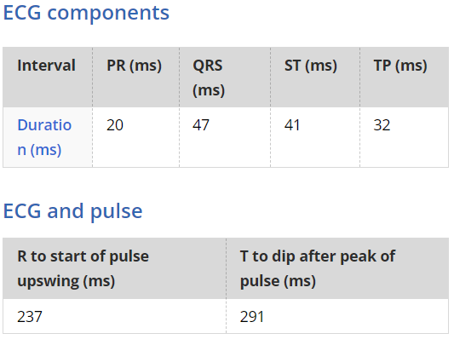
Experiment 1A: ECG and Pulse: With Exercise
